Emily Foreacre
9/27/2025
Professor Hurms
R Statistical Programming Lang
Week 6.1 HW

#Problem 1
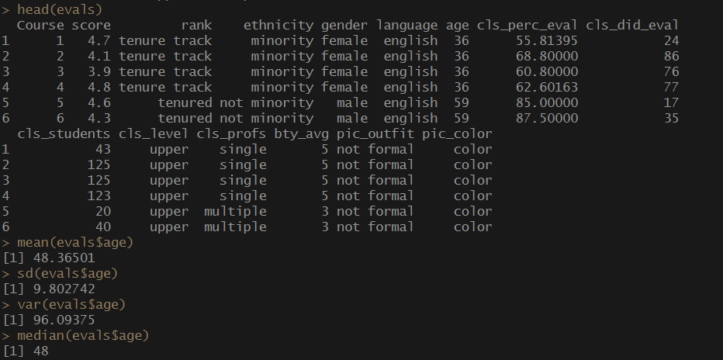
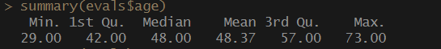
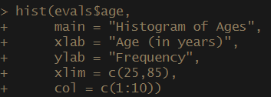
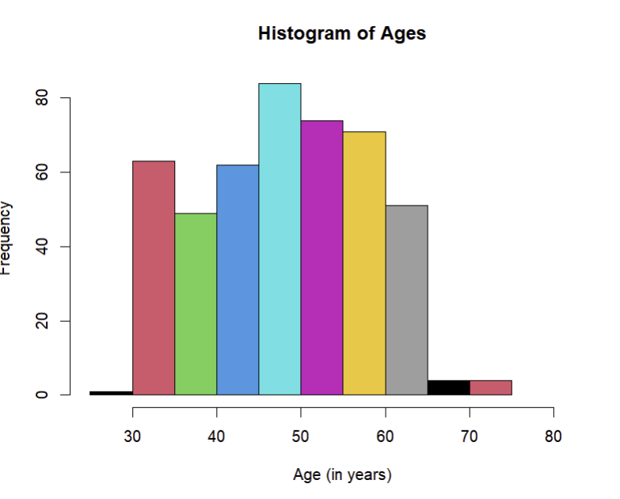
# Ages range from late 20s to early 70s; with the avg being 48. The histogram
# seems to have a normal distribution, we can tell based on the median and mean almost
#being the same, and the length of the dataset is 463.
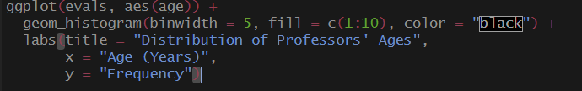
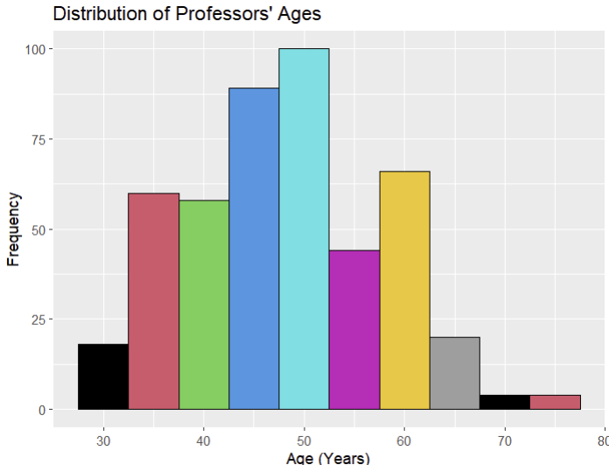

# Problem 2
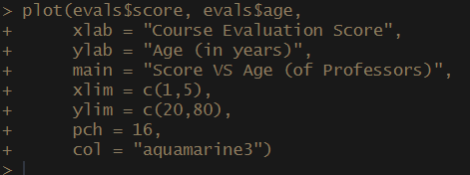

# ?colors
# colors (distinct = FALSE)
# ?pch
# I also used these in my code, but didn’t see a reason to screenshot the output.
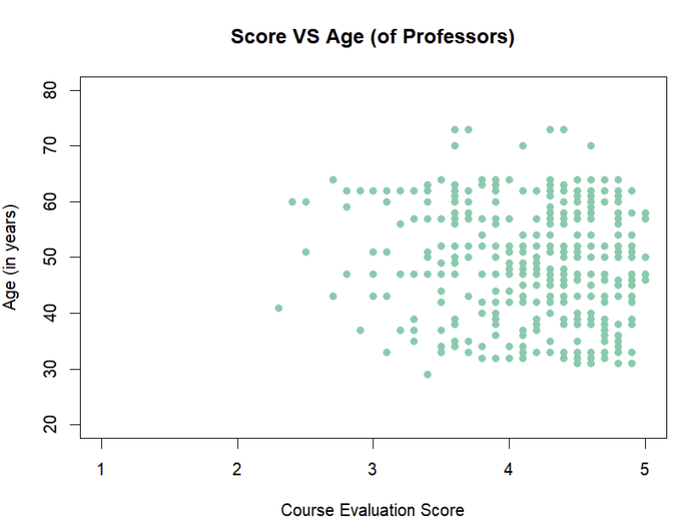
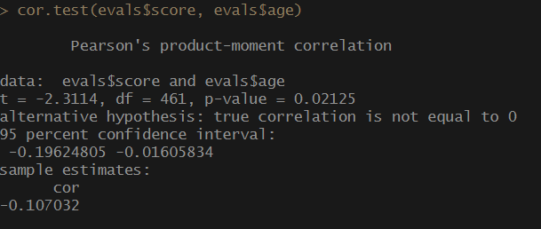
# There is a weak but significant negative association
# between professor age and course evaluation score.
# Older professors tend to receive slightly lower scores.
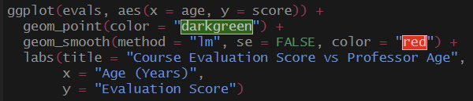
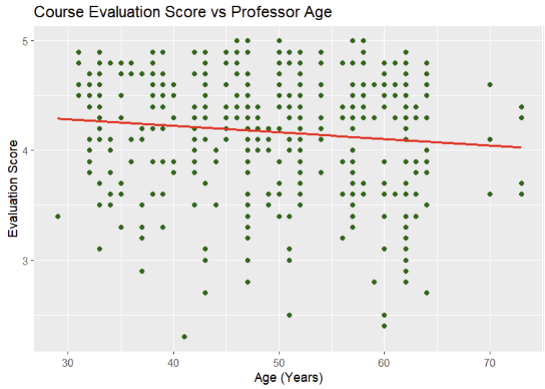
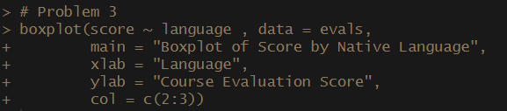
#Problem 3

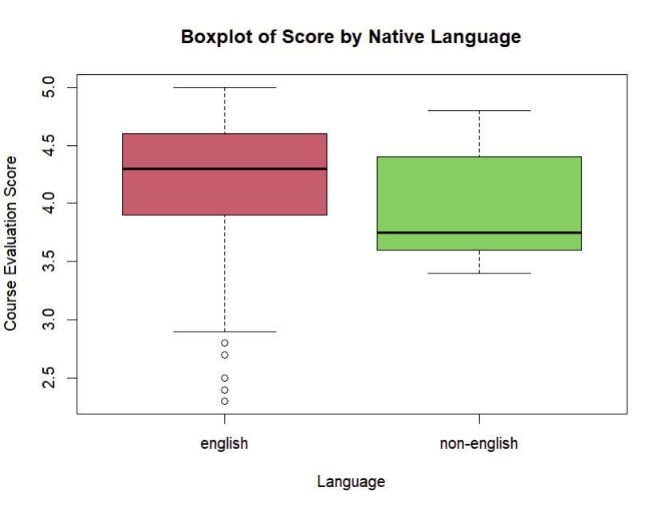

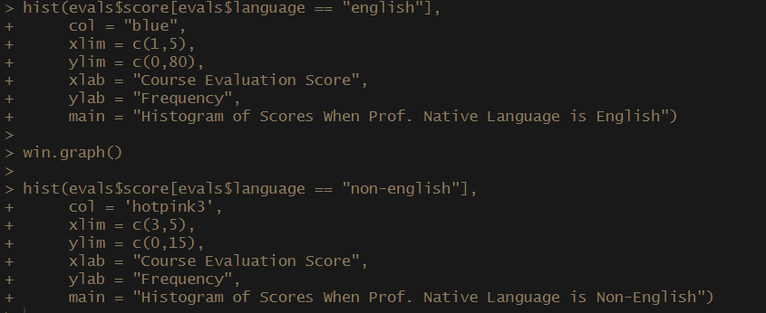
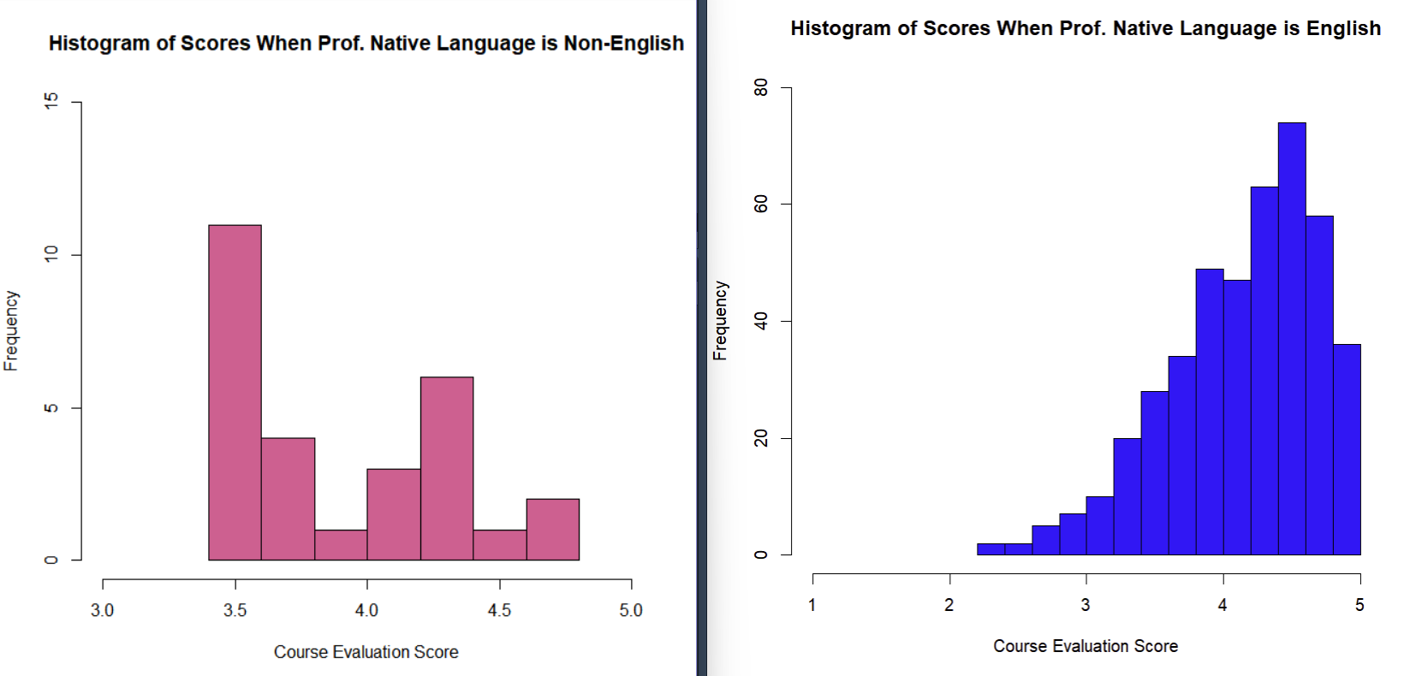
# Visually, there does appear to be a difference in scores when compared
# to the professor’s native language. non-English native speaker has a lower score
# then professors whose native language is English.

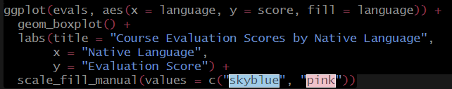
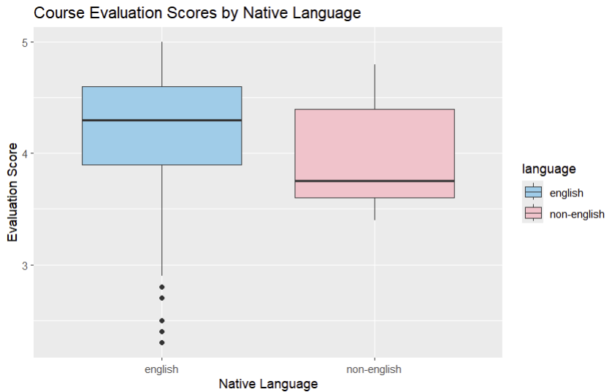
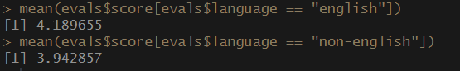
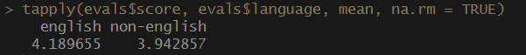
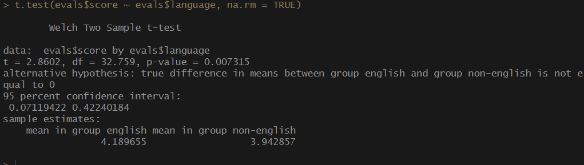
# English native speaking Professors score slightly, but statistically significantly
# higher than professors that are non-English native speakers. With the p-value = 0.007, we # don’t reject the null. I also calculated the median in some code that I must have deleted, # but it was interesting to see that they were even further off from each other.
# Problem 4
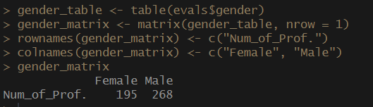
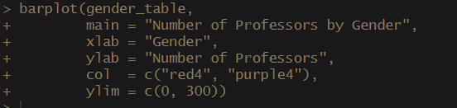
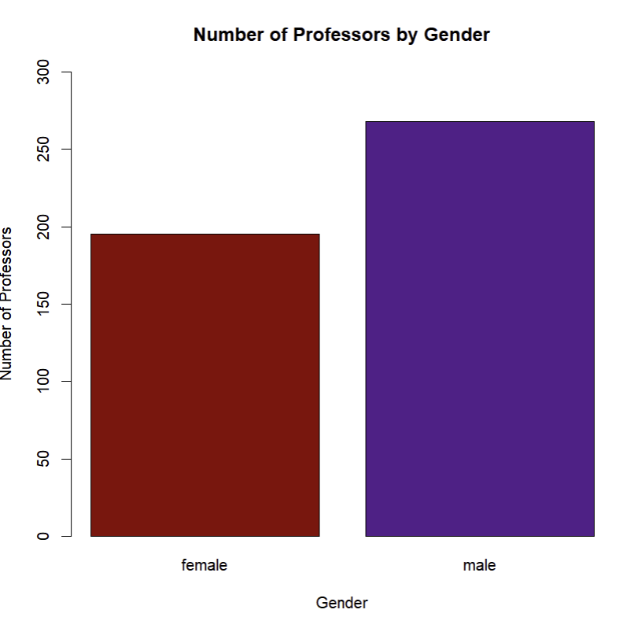
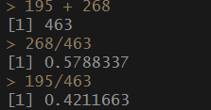
# Male professors outnumber female professors with male professors making up 57%
# of the data set and female professor making up 42%. I manually calculated the #percentages, but I’m sure there’s a way you could add that to the bar graph.

# Problem 5
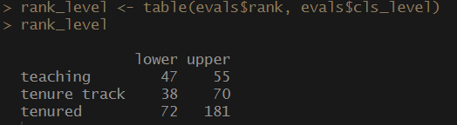
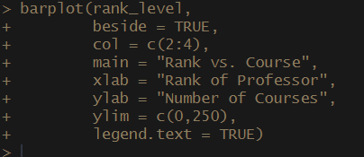
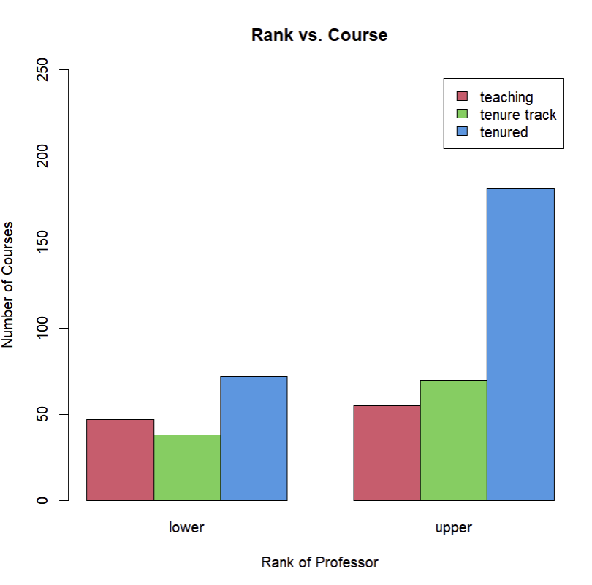

# Seems that in the lower and upper levels, tenured professors make up the
# majority of the courses. As for teaching and tenure track; in the lower ranked professors,
# teaching professors have more courses. In the upper level, tenure track professors have
# more courses.

